Title of your Acoustofluidics paper
Times New Roman 16 pt

Sally Sound^{1,*}, Charles Chip^{1,2}, and Todd Transducer¹ (Times New Roman 13 pt)
Underline the presenting author

¹Department, University, City, Country (Times New Roman 11 pt)
²Company Name, City, Country
*E-mail: flow@somewhere.edu

Introduction
In the introduction to your abstract you should briefly introduce the context of your study. Describe the aim of the work, and mention whether this is an experimental and/or theoretical and/or numerical study. End by highlighting the most important results. References to literature should be made as [1,2].

Length and formatting of the abstract
The abstract is limited to two A4 pages. The margins should be 2 cm on all sides, and all the section headings and main text should be written in Times New Roman font size 11 pt. Please use the abstract template provided at the conference website https://acoustofluidics.net/
The abstract should contain a “Title-Authors-Affiliation” section as described above, then a section called “Introduction”, followed by any number and section titles of the main text as you want, followed by “Conclusion”, if relevant “Acknowledgements” and ending with “References”.
The abstract is limited to two pages. If a longer abstract is submitted, the extra pages will be discarded and only the first two pages are submitted to the scientific committee for review. All abstracts will be reviewed by at least two reviewers. Besides these few rules, no further restrictions apply.

Theory and Experimental procedure
After the introduction, present a detailed description of methods, device structures, and examples of specific results, whether experimental or theoretical. Remember to define all variables when using equations. Figures can be inserted as in Figure 1 or Figure 2.

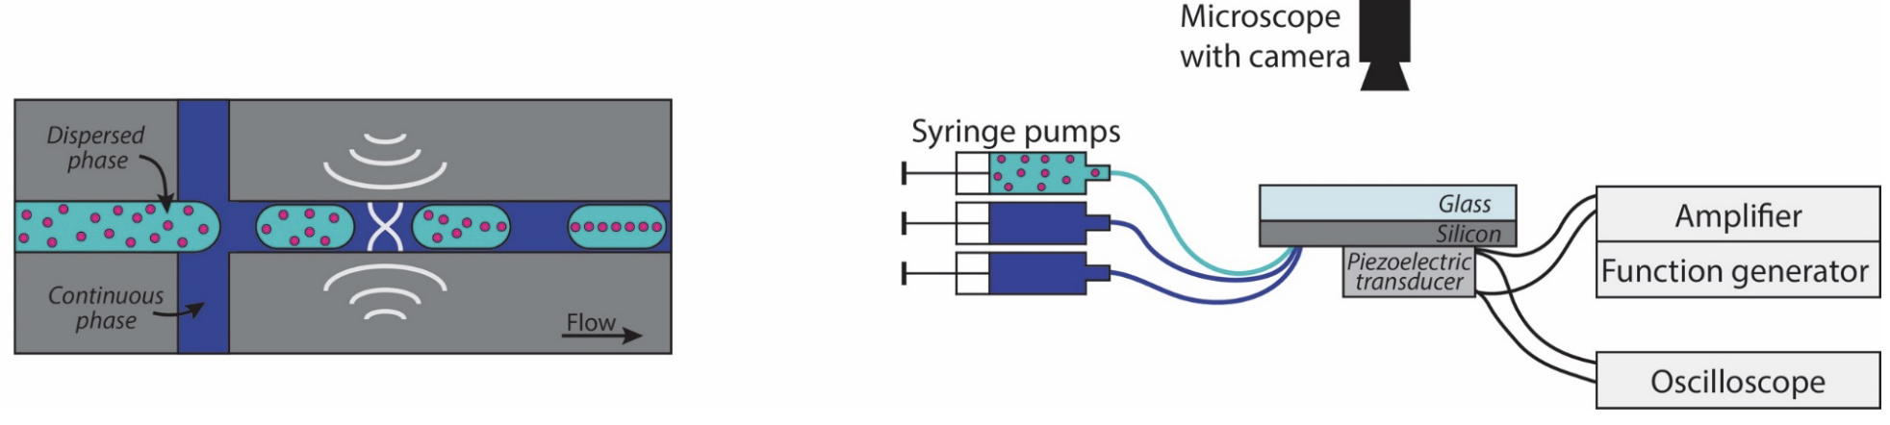 | Figure 1: Schematics of the microfluidic chip and the experimental setup used in the Tenje Lab at UU.  This is an example if you want the figure caption to the right of the figure. Please use Times New Roman font size 10 pt for the figure captions.

Results and Discussion
Here you may present your most important findings.

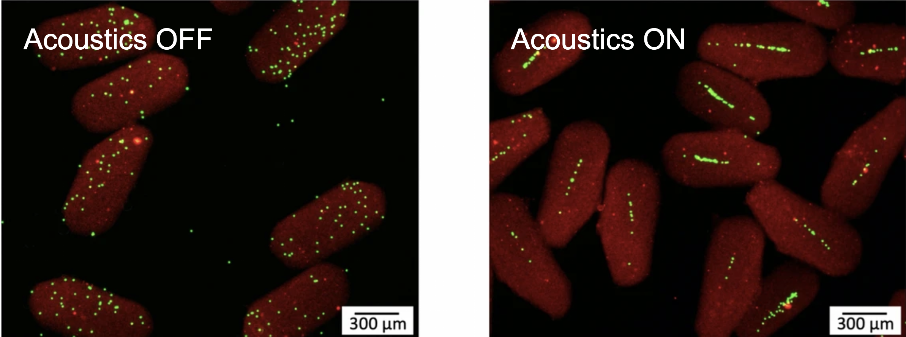

Figure 2: Acoustic focusing of polystyrene beads in hydrogel droplets. Work by A. Fornell et al. from Tenje Lab, UU.

This is an example if you want the figure caption underneath. Please use Times New Roman font size 10 pt for the figure captions.

Conclusion
We have found some amazing results which we are looking forward to presenting at Acoustofluidics 2024 conference in Uppsala, Sweden. The deadline for submitting the abstract is April 1, 2024. Visit https://acoustofluidics.net/authors/abstract_submission.html to submit your abstract, please submit it in pdf format. The abstracts will be shared electronically with all conference participants and uploaded to the conference website for future reference. Please consider this when writing up your results and avoid including anything you do not wish to be publicly disclosed.

Acknowledgements
The organizing committee thanks you for your interest in the Acoustofluidics 2024 conference and we look forward to learning about your research.

References (Times New Roman 10 pt)
[1] E. Xample, S. Mart, J. Irreproducible Results, 56 126 (2018)
[2] D. Wiseguy, Fundamental of miniaturisation (Science Press, New York 2000)
[3] B. Nerd, W.R. Freak, Proc. 50th Annual Turbulence Conference, London, UK, 2022, pp. 56-60

